import nltk

paragraph = """I have three visions for India. In 3000 years of our history, people from all over
the world have come and invaded us, captured our lands, conquered our minds.
From Alexander onwards, the Greeks, the Turks, the Moguls, the Portuguese, the British,
the French, the Dutch, all of them came and looted us, took over what was ours.
Yet we have not done this to any other nation. We have not conquered anyone.
We have not grabbed their land, their culture,
their history and tried to enforce our way of life on them.
Why? Because we respect the freedom of others.That is why my
first vision is that of freedom. I believe that India got its first vision of
this in 1857, when we started the War of Independence. It is this freedom that
we must protect and nurture and build on. If we are not free, no one will respect us.
My second vision for India’s development. For fifty years we have been a developing nation.
It is time we see ourselves as a developed nation. We are among the top 5 nations of the world
in terms of GDP. We have a 10 percent growth rate in most areas. Our poverty levels are falling.
Our achievements are being globally recognised today. Yet we lack the self-confidence to
see ourselves as a developed nation, self-reliant and self-assured. Isn’t this incorrect?
I have a third vision. India must stand up to the world. Because I believe that unless India
stands up to the world, no one will respect us. Only strength respects strength. We must be
strong not only as a military power but also as an economic power. Both must go hand-in-hand.
My good fortune was to have worked with three great minds. Dr. Vikram Sarabhai of the Dept. of
space, Professor Satish Dhawan, who succeeded him and Dr. Brahm Prakash, father of nuclear material.
I was lucky to have worked with all three of them closely and consider this the great opportunity of my life.
I see four milestones in my career"""

# Cleaning the texts
import re # re library will use for regular expression
from nltk.corpus import stopwords
from nltk.stem.porter import PorterStemmer
from nltk.stem import WordNetLemmatizer

ps = PorterStemmer()
wordnet=WordNetLemmatizer()
sentences = nltk.sent_tokenize(paragraph)

corpus = []

# Create the empty list name as corpus because after cleaned the data, corpus will store this clean data

for i in range(len(sentences)):
review = re.sub('[^a-zA-Z]', ' ', sentences[i])
review = review.lower()
review = review.split()
# review = [ps.stem(word) for word in review if not word in set(stopwords.words('english'))]
review = [wordnet.lemmatize(word) for word in review if not word in set(stopwords.words('english'))]
review = ' '.join(review)
corpus.append(review)

# Creating the Bag of Words model

# Also we called as document matrix
from sklearn.feature_extraction.text import CountVectorizer
cv = CountVectorizer()
X_bow = cv.fit_transform(corpus).toarray()

from sklearn.feature_extraction.text import TfidfVectorizer
tf = TfidfVectorizer()
X_tf = tf.fit_transform(corpus).toarray()

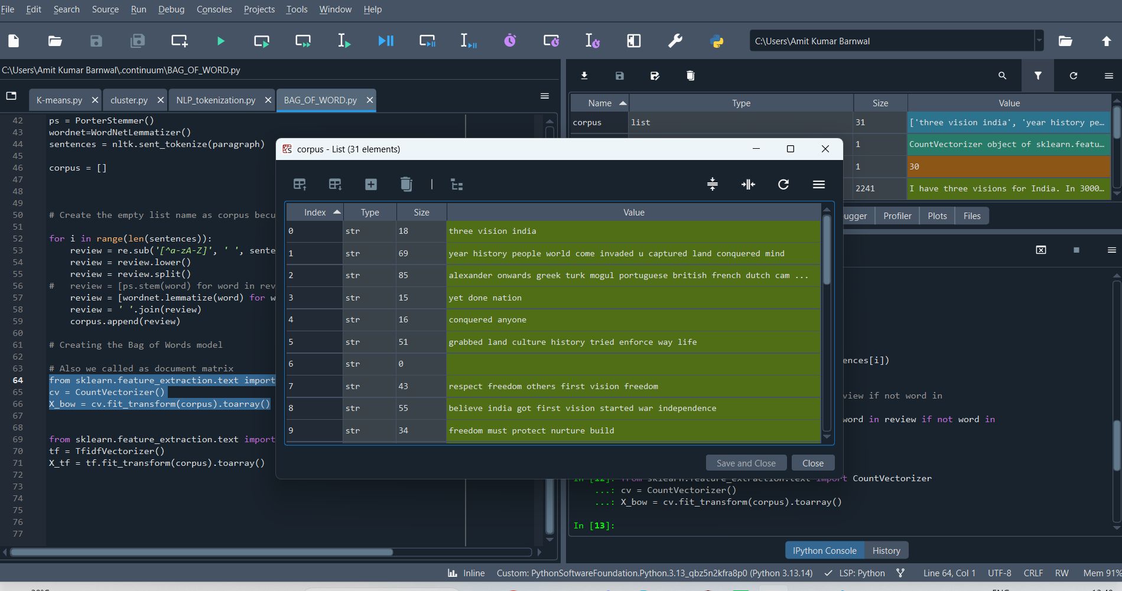
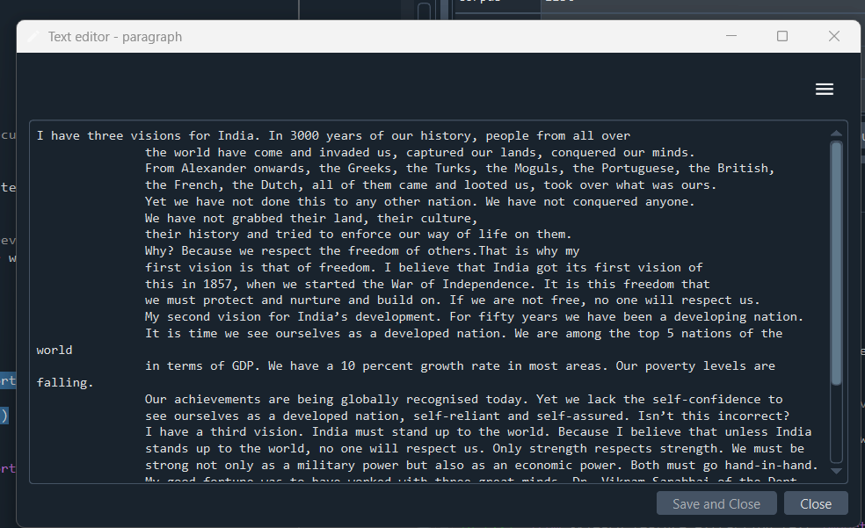
Good one to understand

import nltk
import re

from nltk.corpus import stopwords
from nltk.stem import WordNetLemmatizer
from sklearn.feature_extraction.text import CountVectorizer, TfidfVectorizer

paragraph = """I have three visions for India. In 3000 years of our history, people from all over
the world have come and invaded us, captured our lands, conquered our minds.
From Alexander onwards, the Greeks, the Turks, the Moguls, the Portuguese, the British,
the French, the Dutch, all of them came and looted us, took over what was ours.
Yet we have not done this to any other nation. We have not conquered anyone.
We have not grabbed their land, their culture,
their history and tried to enforce our way of life on them.
Why? Because we respect the freedom of others.That is why my
first vision is that of freedom. I believe that India got its first vision of
this in 1857, when we started the War of Independence. It is this freedom that
we must protect and nurture and build on. If we are not free, no one will respect us.
My second vision for India’s development. For fifty years we have been a developing nation.
It is time we see ourselves as a developed nation. We are among the top 5 nations of the world
in terms of GDP. We have a 10 percent growth rate in most areas. Our poverty levels are falling.
Our achievements are being globally recognised today. Yet we lack the self-confidence to
see ourselves as a developed nation, self-reliant and self-assured. Isn’t this incorrect?
I have a third vision. India must stand up to the world. Because I believe that unless India
stands up to the world, no one will respect us. Only strength respects strength. We must be
strong not only as a military power but also as an economic power. Both must go hand-in-hand.
My good fortune was to have worked with three great minds. Dr. Vikram Sarabhai of the Dept. of
space, Professor Satish Dhawan, who succeeded him and Dr. Brahm Prakash, father of nuclear material.
I was lucky to have worked with all three of them closely and consider this the great opportunity of my life. I see four milestones in my career"""

# --------------------------------
# Text preprocessing
# --------------------------------

lemmatizer = WordNetLemmatizer()
stop_words = set(stopwords.words('english'))

sentences = nltk.sent_tokenize(paragraph)

corpus = []

for sentence in sentences:

# Remove non-alphabetic characters
review = re.sub('[^a-zA-Z]', ' ', sentence)

# Convert to lowercase
review = review.lower()

# Split into words
words = review.split()

# Remove stopwords + lemmatize
words = [
lemmatizer.lemmatize(word)
for word in words
if word not in stop_words
]

# Join words back into sentence
review = ' '.join(words)

corpus.append(review)

# --------------------------------
# Bag of Words
# --------------------------------

cv = CountVectorizer()

X_bow = cv.fit_transform(corpus).toarray()

print("Bag of Words shape:", X_bow.shape)
print(X_bow)

# --------------------------------
# TF-IDF
# --------------------------------

tf = TfidfVectorizer()

X_tf = tf.fit_transform(corpus).toarray()

print("TF-IDF shape:", X_tf.shape)
print(X_tf)

Paragraph
↓
Sentence Tokenization
↓
Individual sentences
↓
Remove punctuation
↓
Lowercase
↓
Remove stopwords
↓
Lemmatization
↓
Corpus
↓
┌───────────────┐
↓ ↓
CountVectorizer TfidfVectorizer
↓ ↓
X_bow X_tf

Yeh Python code ek complete NLP Text Preprocessing aur Feature Extraction Pipeline hai. Is script ke har ek term aur function ki detail-wise explanation niche di gayi hai:

1. Library Imports & Initialization
- import nltk: Natural Language Toolkit library ko import karta hai jo text processing ke liye use hoti.
- import re: Regular Expression library ko import karta hai jo text se patterns (jaise punctuation ya numbers) dhoondne aur hatane ke kaam aati hai.
- stopwords: English ke aam words (jaise 'is', 'the', 'and', 'at' etc.) ki list deta hai jo sentence mein baar-bar aate hain lekin khas meaning nahi rakhte.
- PorterStemmer: Words ko unke root/stem form mein reduce karne wala algorithm (jaise 'running' ko 'run' banana).
- WordNetLemmatizer: Words ko unke dictionary-based root form (lemma) mein convert karta hai jo stemming se zyada accurate hota hai.

2. Sentence Tokenization
- sentences = nltk.sent_tokenize(paragraph): Poore paragraph ko ek-ek sentence mein tod (tokenize) kar ek list mein store kar deta hai.

3. Text Cleaning & Processing Loop (corpus creation)
- corpus = []: Ek khali list banata hai jisme sabhi cleaned sentences (documents) ko ek-ek karke save kiya jayega.
- re.sub('[^a-zA-Z]', ' ', sentences[i]): Regular expression ka use karke alphabet (a-z aur A-Z) ke alawa baaki sabhi cheezon (jaise numbers 3000, commas ,, full stops .) ko space se replace kar deta hai.
- review.lower(): Sabhi capital letters ko lowercase (chote aksharo) mein convert kar deta hai taaki "India" aur "india" ko ek hi word mana jaye.
- review.split(): Clean kiye gaye sentence ko space ke base par tod kar individual words ki list bana deta hai.
- wordnet.lemmatize(word): Words par lemmatization apply karta hai.
- if not word in set(stopwords.words('english')): Check karta hai ki word stopword toh nahi hai; agar hai, toh use hata deta hai.
- ' '.join(review): Processed words ki list ko wapas space se jod kar ek single string bana deta hai.
- corpus.append(review): Final cleaned string ko corpus list mein add kar deta hai.

4. Feature Extraction (Numerical Conversion)
Machine learning models text ko direct nahi samajh sakte, isliye text ko numbers mein convert karna padta hai:
- CountVectorizer() (Bag of Words / BoW):
  - Yeh text ko ek Document-Term Matrix mein convert karta hai.
  - Har word ki frequency (woh sentence mein kitni baar aaya hai) count karta hai aur matrix banata hai (X_bow).
- TfidfVectorizer() (Term Frequency-Inverse Document Frequency):
  - Yeh dekhta hai ki ek word kisi specific sentence mein kitna important hai, poore corpus ke comparison mein.
  - Jo words har jagah aate hain (jaise common words), unka weight kam kar deta hai aur jo unique words hote hain unhe higher importance deta hai (X_tf).
- .fit_transform(corpus): Corpus par vectorizer ko fit karta hai (vocabulary learn karta hai) aur text ko numerical array mein transform kar deta hai.
- .toarray(): Sparse matrix ko standard 2D NumPy array mein convert karta hai taaki values ko easily print ya inspect kiya ja sake.

